Star-Rotunda

Definition
# Source: AI Source: Provided by: [Data Path: Persons Table -> ID Column: 1, Name_En Column: Motasem Essam] -> From: [ChatGPT] on [7/25/2026]
A Star-Rotunda is a non-convex or star-shaped variation of a rotunda-type polyhedron. It extends the rotunda construction by incorporating star-polygon geometry into its structure, particularly in its polygonal bases.
Unlike an ordinary rotunda, which uses conventional convex polygonal bases, a Star-Rotunda uses a star polygon, such as a pentagram or heptagram, to create a star-like geometric arrangement.
Star-Rotundas form a specialized category of polyhedra. <Cite refs={["turn649936search12","turn649936search2"]}/>

Geometric Structure
# Source: AI Source: Provided by: [Data Path: Persons Table -> ID Column: 1, Name_En Column: Motasem Essam] -> From: [ChatGPT] on [7/25/2026]
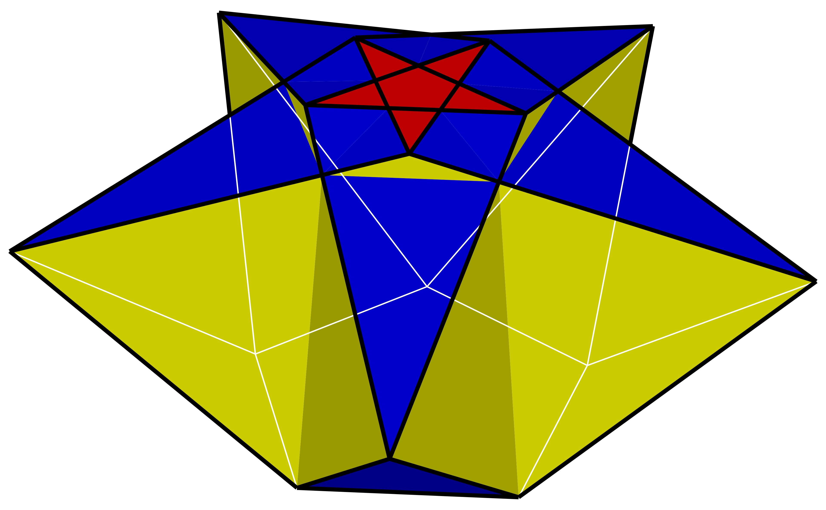
A Star-Rotunda may contain the following structural elements:
- Star-Polygon Base: A polygon with a star-shaped arrangement of edges, such as a pentagram or heptagram.
- Opposite Base: A corresponding polygonal base connected to the star-shaped structure.
- Lateral Faces: Polygonal faces connecting the bases and forming the solid's outer structure.
- Star Arrangement: The vertices and edges follow a star-like rotational pattern around the central axis.
The exact face arrangement depends on the particular star-rotunda construction.

Types of Star-Rotundas
# Source: AI Source: Provided by: [Data Path: Persons Table -> ID Column: 1, Name_En Column: Motasem Essam] -> From: [ChatGPT] on [7/25/2026]
The commonly listed examples are classified according to their star-polygon arrangement:
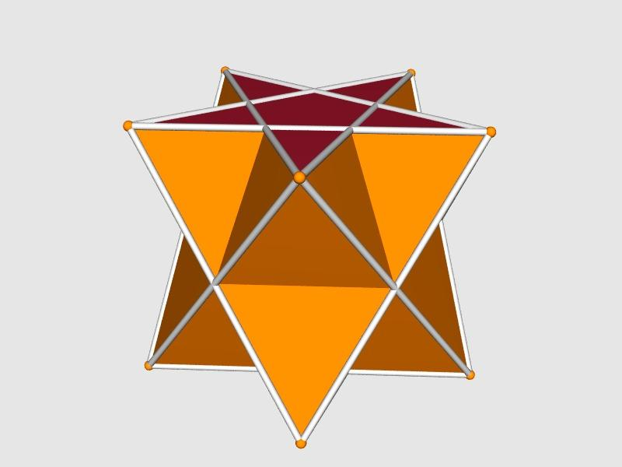

Pentagrammic Rotunda
# Source: AI Source: Provided by: [Data Path: Persons Table -> ID Column: 1, Name_En Column: Motasem Essam] -> From: [ChatGPT] on [7/25/2026]
Based on a pentagrammic arrangement with five principal points.
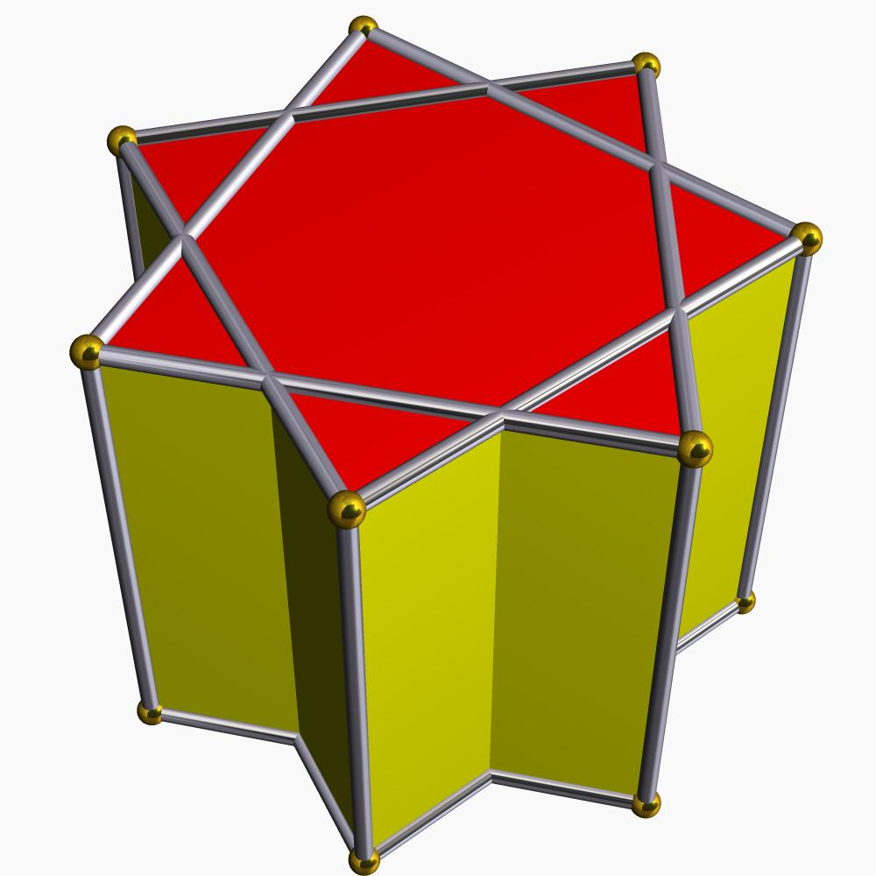

Heptagrammic Rotunda
# Source: AI Source: Provided by: [Data Path: Persons Table -> ID Column: 1, Name_En Column: Motasem Essam] -> From: [ChatGPT] on [7/25/2026]
Based on a heptagrammic arrangement with seven principal points.
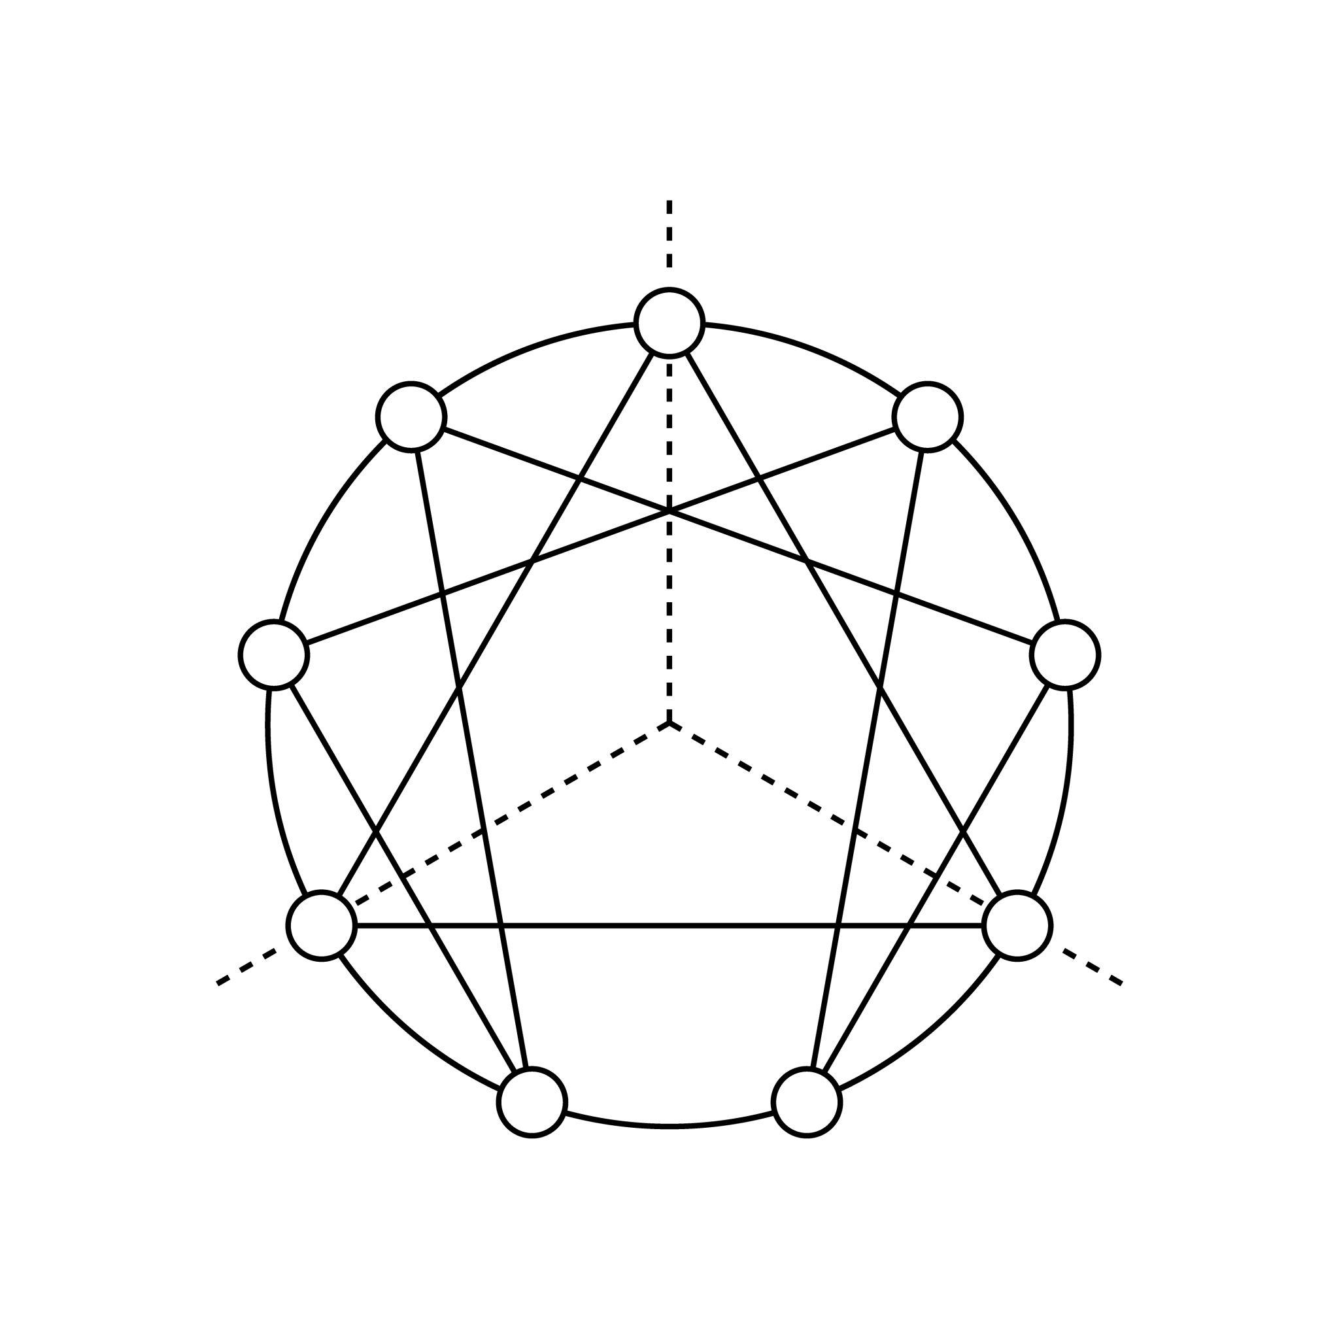

Enneagrammic Rotunda
# Source: AI Source: Provided by: [Data Path: Persons Table -> ID Column: 1, Name_En Column: Motasem Essam] -> From: [ChatGPT] on [7/25/2026]
Based on an enneagrammic arrangement with nine principal points.

Hendecagrammic Rotunda
# Source: AI Source: Provided by: [Data Path: Persons Table -> ID Column: 1, Name_En Column: Motasem Essam] -> From: [ChatGPT] on [7/25/2026]
Based on a hendecagrammic arrangement with eleven principal points.
<Cite refs={["turn649936search12","turn649936search5"]}/>

Geometric Characteristics
# Source: AI Source: Provided by: [Data Path: Persons Table -> ID Column: 1, Name_En Column: Motasem Essam] -> From: [ChatGPT] on [7/25/2026]
- Solid Type: Polyhedron.
- General Form: Star-shaped rotunda construction.
- Polygonal Structure: Star polygons and connecting polygonal faces.
- Symmetry: Depends on the selected star-polygon arrangement.
- Convexity: Generally non-convex or self-intersecting, depending on the construction.
- Geometric Classification: Specialized star-polyhedron family.

Construction of Star-Rotunda

Geometric Instruments Used
# Source: AI Source: Provided by: [Data Path: Persons Table -> ID Column: 1, Name_En Column: Motasem Essam] -> From: [ChatGPT] on [7/25/2026]
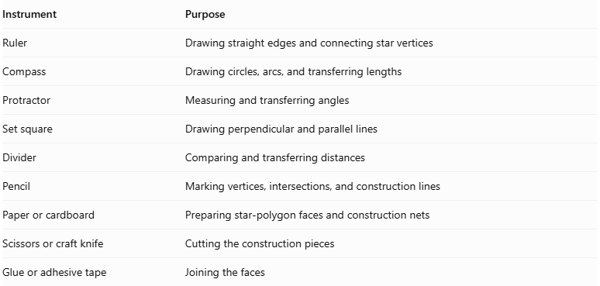
Instrument | Purpose
Ruler | Drawing straight edges and connecting star vertices
Compass | Drawing circles, arcs, and transferring lengths
Protractor | Measuring and transferring angles
Set square | Drawing perpendicular and parallel lines
Divider | Comparing and transferring distances
Pencil | Marking vertices, intersections, and construction lines
Paper or cardboard | Preparing star-polygon faces and construction nets
Scissors or craft knife | Cutting the construction pieces
Glue or adhesive tape | Joining the faces

Instrument-Based Construction Procedures
# Source: AI Source: Provided by: [Data Path: Persons Table -> ID Column: 1, Name_En Column: Motasem Essam] -> From: [ChatGPT] on [7/25/2026]
No coordinate-based construction
The construction uses geometric instruments, star-polygon geometry, measured lengths, angles, and geometric face relationships. It does not use coordinate axes, coordinate points, or coordinate equations.

Select the Star-Rotunda Type
# Source: AI Source: Provided by: [Data Path: Persons Table -> ID Column: 1, Name_En Column: Motasem Essam] -> From: [ChatGPT] on [7/25/2026]
- Select the required Star-Rotunda type.
- Determine the number of principal star points.
- Select the star-polygon connection pattern.
- Identify the required upper and lower star-shaped boundaries.
- Determine the intended symmetry and lateral face arrangement.
For example, a Pentagrammic Rotunda uses five principal points connected in the pentagram pattern.

Construct the Upper Star Polygon
# Source: AI Source: Provided by: [Data Path: Persons Table -> ID Column: 1, Name_En Column: Motasem Essam] -> From: [ChatGPT] on [7/25/2026]
- Draw a circle using a compass.
- Mark the center of the circle.
- Divide the circumference into the required number of equally spaced points.
- Number the points consecutively.
- Use a ruler to connect the points according to the selected star-polygon pattern.
- Continue the connections until the star boundary is complete.
- Mark the outer tips and inner intersections.
For a pentagram, connect every second point of an inscribed regular pentagon.

Construct the Lower Star-Shaped Boundary
# Source: AI Source: Provided by: [Data Path: Persons Table -> ID Column: 1, Name_En Column: Motasem Essam] -> From: [ChatGPT] on [7/25/2026]
- Draw a second circle using a compass.
- Divide its circumference into the required number of equally spaced points.
- Construct the corresponding star-polygon pattern.
- Adjust the size and orientation according to the selected three-dimensional model.
- Verify the required symmetry between the upper and lower boundaries.

Construct the Lateral Triangular Faces
# Source: AI Source: Provided by: [Data Path: Persons Table -> ID Column: 1, Name_En Column: Motasem Essam] -> From: [ChatGPT] on [7/25/2026]
- Determine the required triangular faces from the selected Star-Rotunda model.
- Draw each triangle using a ruler, compass, and protractor.
- Determine the dimensions of the triangles from the corresponding boundary edges.
- Arrange the triangles around the central axis.
- Match their edges to the appropriate neighboring faces.

Construct the Lateral Pentagonal Faces
# Source: AI Source: Provided by: [Data Path: Persons Table -> ID Column: 1, Name_En Column: Motasem Essam] -> From: [ChatGPT] on [7/25/2026]
- Determine the number and arrangement of pentagonal faces from the selected model.
- Draw each pentagon using geometric instruments.
- Determine the required side lengths and angles.
- Arrange the pentagons between the triangular faces.
- Verify the matching edges and intersections.

Arrange the Star-Shaped Structure
# Source: AI Source: Provided by: [Data Path: Persons Table -> ID Column: 1, Name_En Column: Motasem Essam] -> From: [ChatGPT] on [7/25/2026]
- Position the upper and lower star-shaped boundaries according to the selected model.
- Arrange the lateral triangles and pentagons between them.
- Align the corresponding star points and face boundaries.
- Verify the intended rotational and reflection symmetry.
- Check that all face connections form the intended non-convex polyhedral structure.

Assemble the Solid
# Source: AI Source: Provided by: [Data Path: Persons Table -> ID Column: 1, Name_En Column: Motasem Essam] -> From: [ChatGPT] on [7/25/2026]
- Prepare a verified construction net or separate face pieces.
- Mark the required folding and joining edges.
- Cut out the faces.
- Fold the connecting edges where necessary.
- Join the lateral faces in their correct arrangement.
- Attach the upper and lower star-shaped boundaries.
- Inspect the finished model from several directions.
Construction accuracy: Star-Rotundas require particular attention to crossing edges and intersecting star boundaries. A conventional convex-polyhedron net cannot automatically represent a self-intersecting star arrangement. The face connections and intersection conventions must be established before assembling the model.

Key Points
# Source: AI Source: Provided by: [Data Path: Persons Table -> ID Column: 1, Name_En Column: Motasem Essam] -> From: [ChatGPT] on [7/25/2026]
- Star-Rotundas extend the ordinary rotunda concept using star-polygon geometry.
- Their structures are based on star-shaped arrangements rather than ordinary convex polygon arrangements.
- They are distinct from ordinary rotundas and cupolas.
- Their face counts, edge counts, and vertex counts cannot be assumed to follow the ordinary rotunda formulas without examining each construction.

Main Classification
# Source: AI Source: Provided by: [Data Path: Persons Table -> ID Column: 1, Name_En Column: Motasem Essam] -> From: [ChatGPT] on [7/25/2026]
Solid Geometry
└── Types of Solids
└── Star-Rotunda
└── Types of Star-Rotundas
├── Pentagrammic Rotunda
├── Heptagrammic Rotunda
├── Enneagrammic Rotunda
└── Hendecagrammic Rotunda

Conclusion
# Source: AI Source: Provided by: [Data Path: Persons Table -> ID Column: 1, Name_En Column: Motasem Essam] -> From: [ChatGPT] on [7/25/2026]
A Star-Rotunda is a specialized rotunda-type polyhedron incorporating star-polygon geometry. Its commonly listed examples include Pentagrammic, Heptagrammic, Enneagrammic, and Hendecagrammic Rotundas.
Classification note: These names identify a family of star-rotunda constructions; individual geometric models should be examined separately before assigning exact face compositions or mathematical formulas.

